

INTERNATIONAL ISLAMIC UNIVERSITY MALAYSIA

INFO 2304 - SYSTEM ANALYSIS AND DESIGN

SECTION 2

SEMESTER 1, 2023/2024

PROJECT TITLE: ENERGY MONITORING SYSTEM

GROUP NAME: LEMON GROUP

GROUP MEMBERS:

| ROLE | NAME | MATRIC NUMBER |
| --- | --- | --- |
| FACILITATOR | MUHAMMAD ADAM IDURRAHMAN BIN MOHD SOPI | 2218035 |
| RECORDER | MOHAMMAD MAAZ KHAN | 2020747 |
| COORDINATOR | HAIQAL HANIF BIN MOHD SAHIDI | 2211271 |
| SCRIBER | NUR JANNAH NAI’MAH BINTI ZAINAL | 2211400 |
| RUNNER | AMAN SHAFEEQ LONE | 2219161 |
| CONTRIBUTOR | AHMAD SYAMEER SYAFIQ BIN ZULKEFLI | 2121797 |
| RESEARCHER | NURULAIN BALQIS BT MAT DAUD | 2210980 |

LECTURER: TS. DR. ZAHIDAH BINTI ZULKIFLI

1. **Energy Monitoring System Actors**

| No | Actor(s) | Synonym | Description |
| --- | --- | --- | --- |
| 1 | User | KICT Members | Individuals comprising KICT students, lecturers, and staff who interact with the energy monitoring system. They can register, view reports, and leave feedback on the system. |
| 32 | System Admin | Administrator | Authorized personnel responsible for managing and overseeing the energy monitoring system. Admins can register, activate the system, generate reports, and maintain its functionality. |

Table 1: List of Business Actors in The New Proposed System

1. **Energy Monitoring System Use Cases**

| Use Case name | Description | Participating Actors and Roles | Subsystem |
| --- | --- | --- | --- |
| Register | This use case describes the event of a user or admin registering in the energy monitoring system. | User Admin | - |
| View Report | This use case describes the event of a user viewing energy consumption reports. | User | - |
| Leave Feedback | This use case describes the event of a user providing feedback on the energy monitoring system. | User | - |
| Activate System | This use case describes the event of an admin activating the energy monitoring system. | Admin | Admin Management |
| Generate Report | This use case describes the event of an admin generating energy consumption reports. | Admin | Admin Management |
| Maintain the System | This use case describes the event of an admin maintaining the overall functionality of the energy monitoring system. | Admin | Admin Management |

Table 2: List of Business Requirements of the Energy Monitoring System

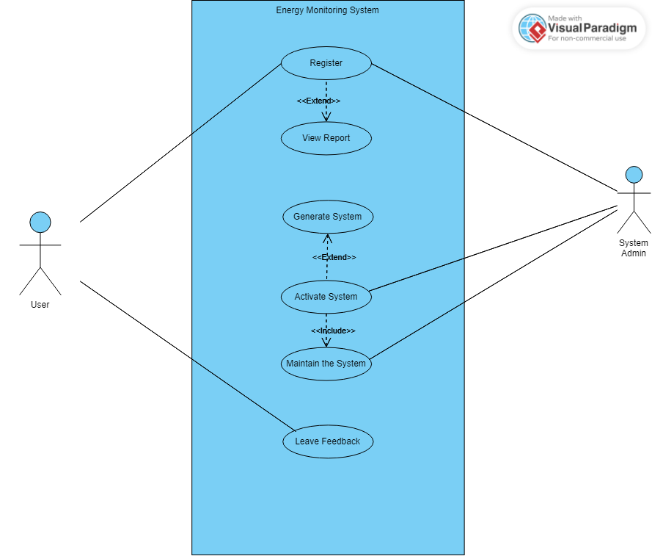

**Figure 1.0 : Use Case Diagram of the Energy Monitoring System**

1. **Use Case Narratives**

**Table 2: Register**

**ENERGY MONITORING SYSTEM**

**Author (s): Mohammad Maaz Khan Date: 25th Dec 2023**

**Version: 1**

| **USE CASE NAME:** | Register | | **USE CASE TYPE** |
| --- | --- | --- | --- |
| **USE CASE ID:** | EMS6-01 | | Business Requirements: **□** |
| **PRIORITY:** | High | | System Analysis:□ |
| **SOURCE:** | Admin | | System Design: **🗹** |
| **PRIMARY BUSINESS ACTOR** | User | | |
| **PRIMARY SYSTEM ACTOR** | System Admin | | |
| **OTHER PARTICIPATING ACTORS:** | * none | | |
| **OTHER INTERESTED STAKEHOLDERS:** | * none | | |
| **DESCRIPTION:** | Event where a user/admin registers | | |
| **PRE-CONDITION:** | 1. User/Admin not registered | | |
| **TRIGGER:** | * Selection of 'Register' option | | |
| **TYPICAL COURSE** | **Actor Action** | **System Response** | |
| **OF EVENTS:** | **Step 1**: User selects 'Register' option. | **Step 2**: System displays registration form | |
|  | Step 3: User enters required information. | Step 4: System validates the information. | |
|  | Step 5 : User submits the form. | Step 6: System registers the user and displays a confirmation message | |
| **ALTERNATE COURSES:** | * none | | |
| **CONCLUSION:** | Registration successful | | |
| **POST-CONDITION:** | User/admin can access the system | | |
| **BUSINESS RULES** | * All fields must be completed to register. * Passwords must meet security requirements. * Users must accept the Terms and Conditions. | | |
| **IMPLEMENTATION CONSTRAINTS AND SPECIFICATIONS** | * System must support concurrent users | | |
| **ASSUMPTIONS:** | * Internet access is available for system registration. | | |
| **OPEN ISSUES:** | * none | | |

**Table 4: View Report Use Case Narrative**

**ENERGY MONITORING SYSTEM**

**Author (s): Haiqal Hanif Bin Mohd Sahidi Date: 25th Dec 2023**

**Version: 1**

| **USE CASE NAME:** | View Report | | **USE CASE TYPE** |
| --- | --- | --- | --- |
| **USE CASE ID:** | EMS6-02 | | Business Requirements: **□** |
| **PRIORITY:** | Low | | System Analysis:□ |
| **SOURCE:** | Admin | | System Design: **🗹** |
| **PRIMARY BUSINESS ACTOR** | User | | |
| **PRIMARY SYSTEM ACTOR** | User | | |
| **OTHER PARTICIPATING ACTORS:** | * Admin | | |
| **OTHER INTERESTED STAKEHOLDERS:** | * - | | |
| **DESCRIPTION:** | View report function is to giving user viewing the energy consumption reports in the system | | |
| **PRE-CONDITION:** | 1. The user registered to the system 2. The Energy Monitoring System is operational | | |
| **TRIGGER:** | * Admin provided the report of the Energy Monitoring System usage to the user | | |
| **TYPICAL COURSE** | **Actor Action** | **System Response** | |
| **OF EVENTS:** | **Step 1**: The use case starts when the user register up in the system | **Step 2**: The system verifies the credentials and grants access to the application | |
|  | Step 3: The user selects the “View Reports” in the menu selection | Step 4:The system navigates to the report page | |
|  | Step 5 : The user viewing the report of the system | Step 6: The system provided the report of the energy consumption reports and all records in the system | |
| **ALTERNATE COURSES:** | * If the specified parameters are invalid, the system provides feedback to the admin, allowing them to correct the inputs. | | |
| **CONCLUSION:** | The user can view the reports of the Energy Monitoring System to make sure they follow up with all of the records in the system. | | |
| **POST-CONDITION:** | The generated report is stored for future reference. | | |
| **BUSINESS RULES** | * The report can only be authorized and perform by the admin of the system | | |
| **IMPLEMENTATION CONSTRAINTS AND SPECIFICATIONS** | * The user can leave and create reports for the system | | |
| **ASSUMPTIONS:** | * .User is allowed to view the reports | | |
| **OPEN ISSUES:** | Providing live report for the user to make sure they keep getting follow up and notice with the system | | |

**Table 5: Leave Feedback Use Case**

**ENERGY MONITORING SYSTEM**

**Author (s): Aman Shafeeq Lone Date: 25/12/23**

**Version: 1**

| **USE CASE NAME:** | Leave Feedback | | **USE CASE TYPE** |
| --- | --- | --- | --- |
| **USE CASE ID:** | EMS6-03 | | Business Requirements: **□** |
| **PRIORITY:** | Medium | | System Analysis:□ |
| **SOURCE:** | Survey | | System Design: **🗹** |
| **PRIMARY BUSINESS ACTOR** | User | | |
| **PRIMARY SYSTEM ACTOR** | Energy Monitoring System | | |
| **OTHER PARTICIPATING ACTORS:** | * Admin | | |
| **OTHER INTERESTED STAKEHOLDERS:** | * - | | |
| **DESCRIPTION:** | The primary objective for this use-case is collecting feedback provided by users who have interacted with the application. | | |
| **PRE-CONDITION:** | The user must have interacted with the application at least once. | | |
| **TRIGGER:** | User decides to leave feedback. | | |
| **TYPICAL COURSE** | **Actor Action** | **System Response** | |
| **OF EVENTS:** | **Step 1**: User access and interacts with the feedback option | **Step 2**: The application displays the feedback form to the user | |
|  | **Step 3**: User provides any sort of feedback | **Step 4**: Application records the feedback | |
|  | **Step 5**: User submits the feedback response | **Step 6**: EMS Stores the feedback for further analysis by admin. | |
| **ALTERNATE COURSES:** | If a user decides to modify their feedback, perhaps due to a change of mind or grammatical correction, they can edit their feedback after submission. | | |
| **CONCLUSION:** | The application successfully receives the feedback and stores it so that it can be viewed. | | |
| **POST-CONDITION:** | User’s feedback is stored in the system | | |
| **BUSINESS RULES** | * Feedback must be authentic | | |
| **IMPLEMENTATION CONSTRAINTS AND SPECIFICATIONS** | * Admin can develop a user-friendly feedback interface | | |
| **ASSUMPTIONS:** | * User is allowed to leave feedback | | |
| **OPEN ISSUES:** | Having suitable database management for all the feedback received and stored. | | |

**Table 6: Activate system use case narrative**

**Energy Monitoring System**

**Author (s): Ahmad Syameer Syafiq bin Zulkefli Date: 25/12/2023**

**Version: 1**

| **USE CASE NAME:** | Activate system | | **USE CASE TYPE** |
| --- | --- | --- | --- |
| **USE CASE ID:** | EMS6-04 | | Business Requirements: **□** |
| **PRIORITY:** | High | | System Analysis:□ |
| **SOURCE:** | admin | | System Design: **🗹** |
| **PRIMARY BUSINESS ACTOR** | Admin | | |
| **PRIMARY SYSTEM ACTOR** | Energy Monitoring System | | |
| **OTHER PARTICIPATING ACTORS:** | * none | | |
| **OTHER INTERESTED STAKEHOLDERS:** | * none | | |
| **DESCRIPTION:** | The system is for admin to activate the monitoring system | | |
| **PRE-CONDITION:** | The system is off | | |
| **TRIGGER:** | The activate button in system activation | | |
| **TYPICAL COURSE** | **Actor Action** | **System Response** | |
| **OF EVENTS:** | **Step 1**: admin log in into the system | **Step 2**: System authenticate Admin credentials | |
|  | **Step 3**: admin open system activation panel | **Step 4:** System navigate to and display the activation panel | |
|  | **Step 5:** Admin activate the system button | **Step 6:** System is activated | |
| **ALTERNATE COURSES:** | 1. The admin wrongly input the login credentials and denied access | | |
|  | 1. The system was not deactivated or stayed on | | |
| **CONCLUSION:** | The admin has control to activate and deactivate the system | | |
| **POST-CONDITION:** | The system is on and admin is able to monitor real time energy consumption | | |
| **BUSINESS RULES** | * The system must always be deactivated when classes are all done | | |
| **IMPLEMENTATION CONTRAINTS AND SPECIFICATIONS** | * Only the admin has access over the activation of the system | | |
| **ASSUMPTIONS:** | * The admin must activate and deactivate the system | | |
| **OPEN ISSUES:** | The admin forgot to deactivate the system and energy consumption is overload | | |

**Table 7: Generate Report Use Case Narrative**

**ENERGY MONITORING SYSTEM**

**Author (s): Nurulain Balqis bt Mat Daud Date: 25th Dec 2023**

**Version: 1**

| **USE CASE NAME:** | Generate report | | **USE CASE TYPE** |
| --- | --- | --- | --- |
| **USE CASE ID:** | EMS6-05 | | Business Requirements: **□** |
| **PRIORITY:** | High | | System Analysis:□ |
| **SOURCE:** | System Database | | System Design: **🗹** |
| **PRIMARY BUSINESS ACTOR** | Admin | | |
| **PRIMARY SYSTEM ACTOR** | Energy Monitoring System | | |
| **OTHER PARTICIPATING ACTORS:** | * - | | |
| **OTHER INTERESTED STAKEHOLDERS:** | * - | | |
| **DESCRIPTION:** | The Generate Report use case enables the system to generate energy consumption reports .The reports provide insights into the lighting system's performance, including usage patterns, energy savings, and any potential issues. | | |
| **PRE-CONDITION:** | 1. The Energy Monitoring System is operational. 2. The admin is logged into the system. 3. Data on energy consumption is available in the system database. | | |
| **TRIGGER:** | The admin requests the generation of a report through the Energy Monitoring System's user interface. | | |
| **TYPICAL COURSE** | **Actor Action** | **System Response** | |
| **OF EVENTS:** | **Step 1**: The use case starts when the admin accesses the Energy Monitoring System's software application using their credentials. | **Step 2**: The system verifies the credentials and grants access to the application | |
|  | Step 3: The admin selects the "Generate Report" option from the application's menu. | Step 4:The system navigates to the report generation module. | |
|  | Step 5 : The system prompts the admin to specify report parameters, such as the date range, specific lighting zones, and type of information required. | Step 6: The system validates the provided parameters to ensure they are within acceptable ranges and formats.  - If validation fails, an error message is displayed, and the admin is prompted to correct the parameters. | |
|  | Step 7: The admin waits for validation from the system. | Step 8: Upon successful validation, the system retrieves relevant data from the database, including energy consumption patterns based on motion sensor data. | |
|  | Step 9 : The admin can view the report. | Step 10 : The system presents the report in a user-friendly format for the admin to review. | |
| **ALTERNATE COURSES:** | * If there is an issue with data retrieval, an error message is displayed, and the admin is prompted to try again or contact support. * If the specified parameters are invalid, the system provides feedback to the admin, allowing them to correct the inputs. | | |
| **CONCLUSION:** | The admin can review and analyze the generated report to make informed decisions regarding energy consumption patterns and optimize the lighting system's efficiency. | | |
| **POST-CONDITION:** | The generated report is stored for future reference. | | |
| **BUSINESS RULES** | * Reports can only be generated by authorized users with the role of admin. | | |
| **IMPLEMENTATION CONSTRAINTS AND SPECIFICATIONS** | * The Energy Monitoring System should operate with minimal resource consumption | | |
| **ASSUMPTIONS:** | * Administrators have the necessary permissions to view and analyze the report. | | |
| **OPEN ISSUES:** | Implement a real-time alerting system to notify admins of immediate issues such as malfunctioning sensors or sudden spikes in energy consumption. | | |

**Table 8: Maintain the System Use Case Narrative**

**ENERGY MONITORING SYSTEM**

**Author (s): Nur Jannah Nai’mah binti Zainal Date: 25th Dec 2023**

**Version: 1**

| **USE CASE NAME:** | Maintain the system | | **USE CASE TYPE** |
| --- | --- | --- | --- |
| **USE CASE ID:** | EMS6-06 | | Business Requirements: **□** |
| **PRIORITY:** | High | | System Analysis:□ |
| **SOURCE:** | Admin | | System Design: **🗹** |
| **PRIMARY BUSINESS ACTOR** | Admin | | |
| **PRIMARY SYSTEM ACTOR** | Admin | | |
| **OTHER PARTICIPATING ACTORS:** | * - | | |
| **OTHER INTERESTED STAKEHOLDERS:** | * - | | |
| **DESCRIPTION:** | This use case encompasses the activities related to the ongoing maintenance and management of the energy monitoring system by the admin. | | |
| **PRE-CONDITION:** | 1. The admin is logged into the system. 2. The energy monitoring system is operational. | | |
| **TRIGGER:** | Admin identifies the need for system maintenance, updates, or enhancements. | | |
| **TYPICAL COURSE** | **Actor Action** | **System Response** | |
| **OF EVENTS:** | **Step 1**: The use case starts when the admin opts to perform system maintenance | **Step 2**: The system provides access to maintenance tools and functionalities. | |
|  | **Step 3**: Admin reviews system logs and identifies any potential issues or areas for improvement. | **Step 4**: The system presents detailed logs and diagnostic information. | |
|  | **Step 5**: Admin applies updates or patches to ensure the system's security and performance. | **Step 6**: The system updates its components and notifies the admin upon completion. | |
|  | **Step 7**: Admin monitors system performance and addresses any identified issues. | **Step 8**: The system provides confirmation and status updates. | |
| **ALTERNATE COURSES:** | If the admin identifies critical issues, they may initiate emergency maintenance procedures, temporarily taking the system offline if necessary. | | |
| **CONCLUSION:** | The admin concludes the maintenance activities, ensuring that the energy monitoring system is in optimal condition. | | |
| **POST-CONDITION:** | The energy monitoring system has undergone the necessary maintenance or updates.  The system remains operational and stable. | | |
| **BUSINESS RULES** | * Maintenance tasks should be performed during low system usage periods to minimize disruption. | | |
| **IMPLEMENTATION CONSTRAINTS AND SPECIFICATIONS** | * Maintenance activities should align with system architecture and specifications. | | |
| **ASSUMPTIONS:** | * The admin has the necessary permissions and knowledge to perform system maintenance. | | |
| **OPEN ISSUES:** | Regular backups are in place to mitigate data loss during maintenance. | | |

1. **Activity Diagram**

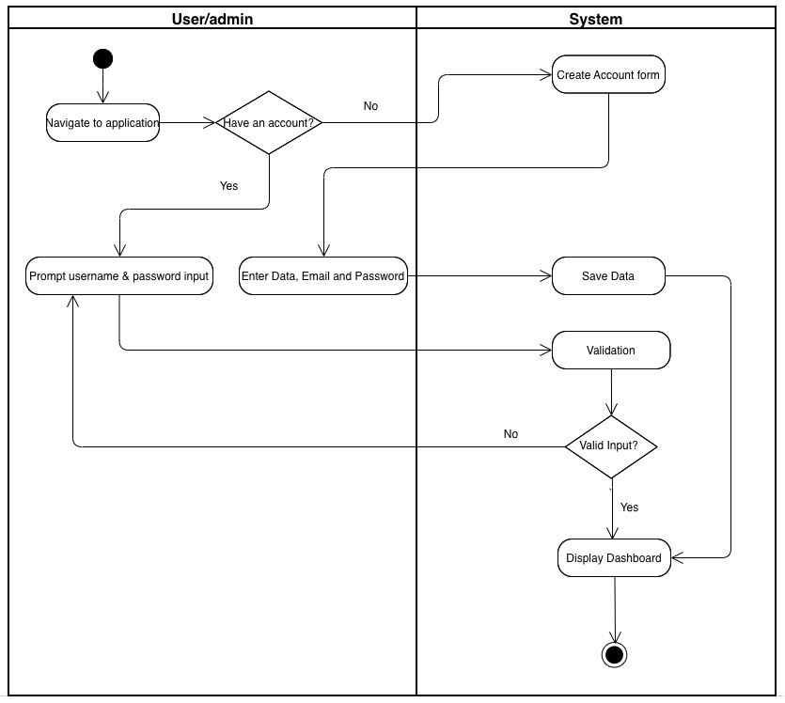

**Figure 2: Register Activity Diagram**

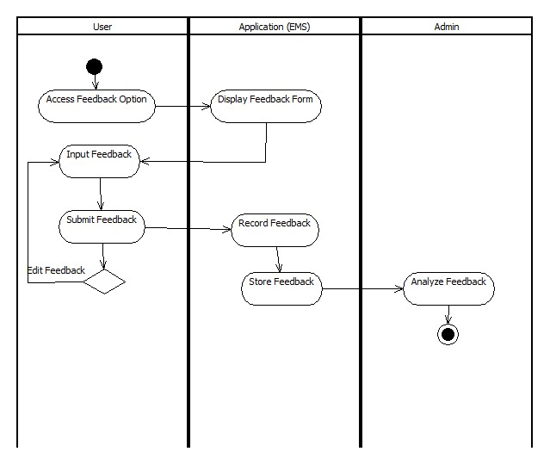

**Figure 3: Leave Feedback Activity Diagram**

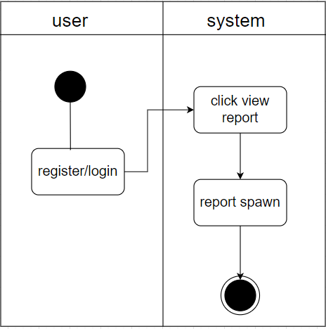

**Figure 4: View Report Activity Diagram**

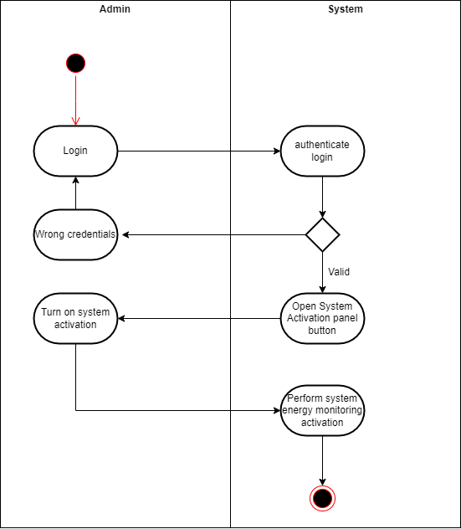

**Figure 5: Activate system activity diagram**

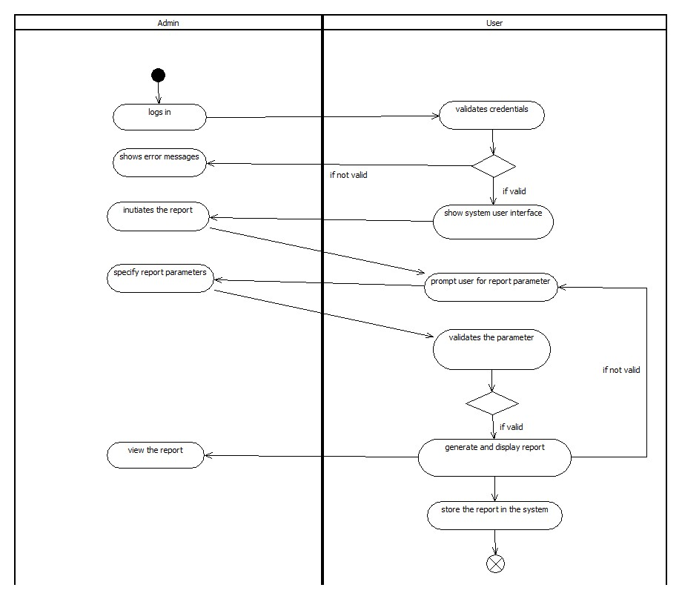

**Figure 6: Generate Report Activity Diagram**

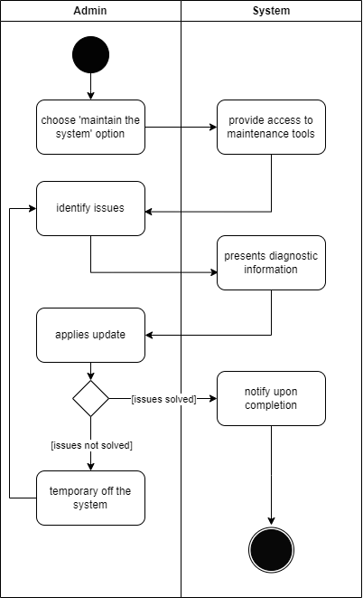

**Figure 7: Maintain the System Activity Diagram**

1. **Sequence Diagram**

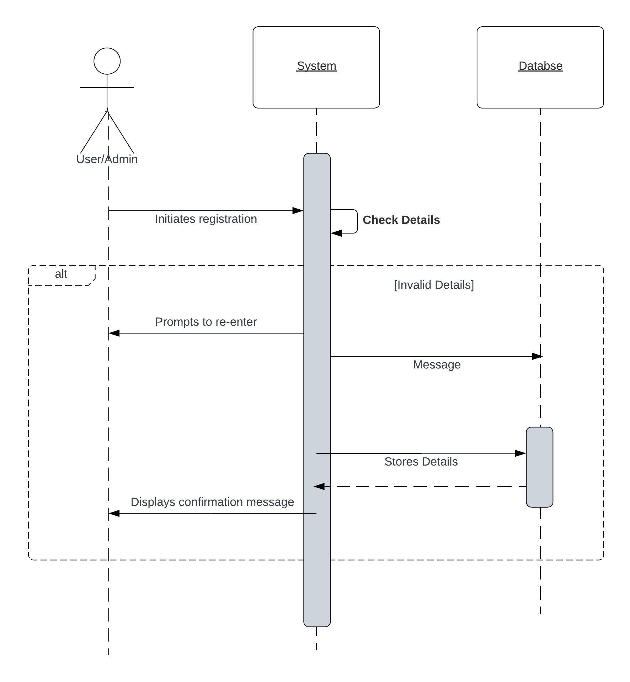

**Figure 7: Registration Sequence Diagram**

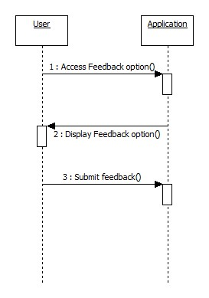

**Figure 8: Leave Feedback Sequence Diagram**

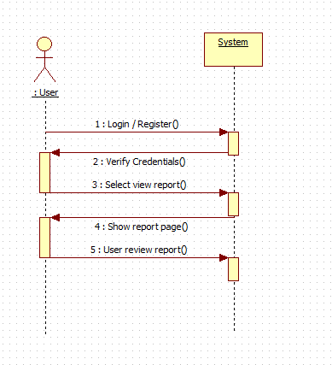

**Figure 9: View Report Sequence Diagram**

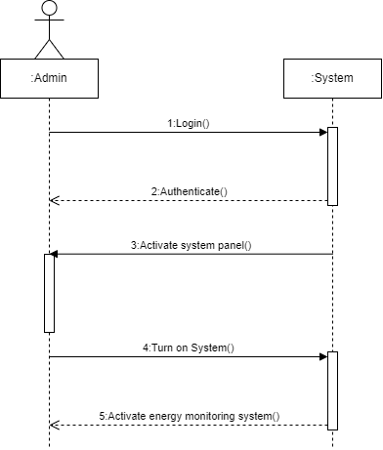

**Figure 10: Activate system activity diagram**

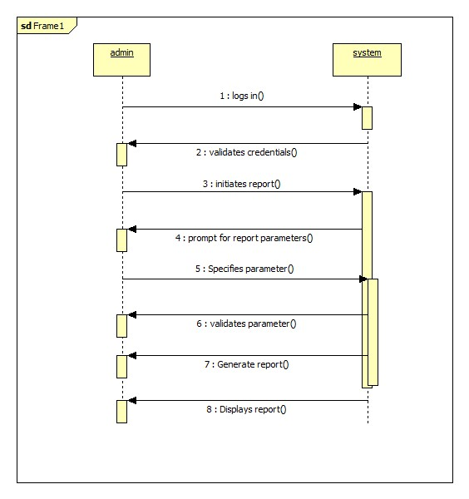

**Figure 11: Generate Report Sequence Diagram**

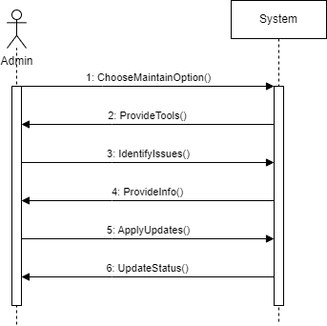

**Figure 12: Maintain the System Sequence Diagram**

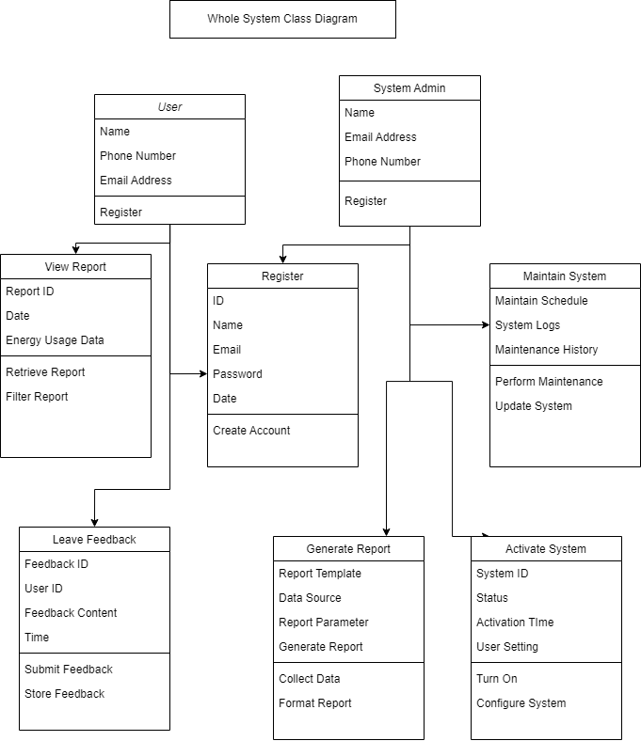

**Figure 13 : Class Diagram of the Energy Monitoring System**